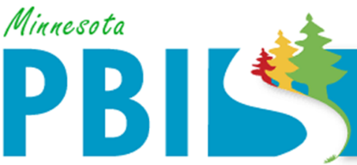

2021-2022 Minnesota PBIS District Recognition
In addition to individual school recognition, districts that are coordinating and supporting their PBIS schools are invited to apply for district recognition. To be identified for District PBIS Recognition, districts must demonstrate capacity for coordination, training, coaching and evaluation to support schools in their district to implement School-Wide Positive Behavioral Interventions and Supports (SW-PBIS).
There are two levels of recognition at the district level. The first is to highlight districts that are in progress towards sustaining implementation and have multiple schools measuring fidelity annually. The second is to highlight districts that have demonstrated exemplar district capacity with over 60% of schools implementing SW-PBIS with fidelity as measure annually.

Three (3) districts are being recognized for Sustaining Exemplar District capacity:
Cambridge Isanti Schools, District 0911 has nine (9) schools and programs in the district. All nine (9) schools and programs have been trained to implement PBIS.
- All nine (9) schools have measured fidelity in the past year, and
- Seven (7) of those are implementing SW-PBIS at Tier 1 with fidelity this year.
Osseo Area Schools, District 279 has twenty-eight (28) schools or programs in the district. All twenty-eight (28) schools have been trained to implement PBIS.
- Twenty-six (26) schools have measured fidelity in the past year, and
- Twenty-three (23) of those are implementing SW-PBIS at Tier 1 with fidelity this year.
St. Cloud Area Schools, District 742 has fourteen (14) schools and programs in the district. All fourteen (14) schools and programs have been trained to implement PBIS.
- Eleven (11) schools have measured fidelity in the past year, and
- Ten (10) of those are implementing SW-PBIS at Tier 1 with fidelity this year.
Two (2) districts are being recognized for progressing towards Sustaining Implementation
Burnsville Public Schools, District 191 has twelve (12) schools and programs in the district. All twelve (12) schools and programs have been trained to implement PBIS.
- Nine (9) schools have measured fidelity in the past year, and
- Six (6) of those are implementing SW-PBIS at Tier 1 with fidelity this year.
Waterville-Elysian-Morristown Schools, District 2143 has four (4) schools and programs in the district. Three (3) schools and programs have been trained to implement PBIS.
- Three (3) schools have measured fidelity in the past year, and
- Two (2) of those are implementing SW-PBIS at Tier 1 with fidelity this year.

