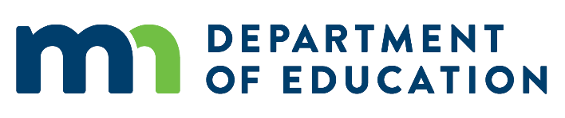
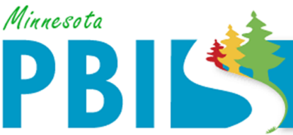

2016-2017 Minnesota PBIS District Recognition
In addition to individual school recognition, districts that are coordinating and supporting their PBIS schools are invited to apply for district recognition. To be identified for District PBIS Recognition, districts must demonstrate capacity for coordination, training, coaching and evaluation to support schools in their district to implement SW-PBIS.
There are two levels of recognition at the district level. The first is to highlight districts that are in progress towards sustaining implementation and have multiple schools measuring fidelity annually. The second is to highlight districts that have demonstrated exemplar district capacity with over 60% of schools implementing SW-PBIS with fidelity as measure annually.

There is one district being recognized as 2016-2017 Exemplar District Capacity PBIS District:
Eastern Carver County Schools
Eastern Carver County Schools has 15 schools in the district. All 15 schools have been trained in PBIS. 14 schools have measured fidelity in the past year and all f14 are implementing SW-PBIS at Tier 1 with fidelity.

There are two districts being recognized as progressing in 2016-2017 toward sustaining implementation:
Saint Cloud
St. Cloud Area School District has 16 schools in the district. All 16 have been trained in PBIS. 15 schools have measured fidelity in the past year and 9 of those are implanting SW-PBIS at Tier 1 with fidelity.
Saint Paul
Saint Paul Public Schools has 63 schools in the district. 30 schools have been trained in PBIS through the state cohort model and an additional 24 have been trained internally. 43 schools measured fidelity in the past year and 35 of those are implementing SW-PBIS at Tier 1 with fidelity.

